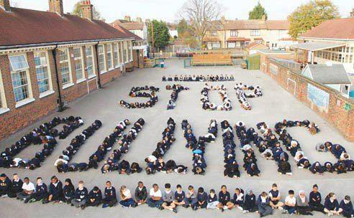
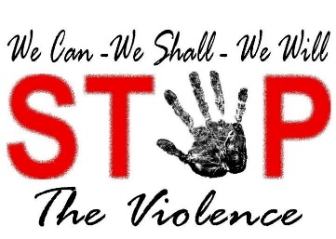
NO BULLYING AND VIOLENCE DAY!
18th of March 2016

Everyday someone is violently attacked or bullied so we need to stop this now. Read more to see what you can do to stop this from happening to people all over the world.
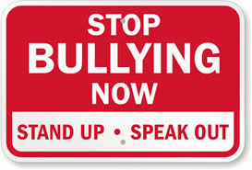
Bullies: Bullies intend to say mean things up front to people who look like they can`t defended themselves.
Bullying: Bullying is when you repetitively get mean things said to you and they have also said mean things about you behind your back. If you just get told a couple of mean things and it does not happen again it is not called bullying it is just called teasing or someone being mean to you.

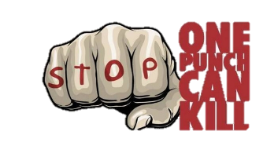
Violence: Violence often ends in someone getting seriously hurt at home, in a public places or even in the school grounds. Violence sometimes leads to death or serious injury. Violence can happen with anyone at any time.
So if you see somebody being mean to somebody in the school yard go up to them and say`` Hey don’t be mean to him/her you are really hurting their feelings” and if you see or hear somebody getting violently attacked tell an adult straight away then call 000 for the police and tell them what you heard or saw and you might save a life or someone from getting seriously injured.
Stand up for your school mates, family and even strangers.
EVERYBODY MATTERS
BULLYING AND VIOLENCE NEEDS TO STOP!!! LETS LIVE IN PEACE!!!
By Paige & Olivia

